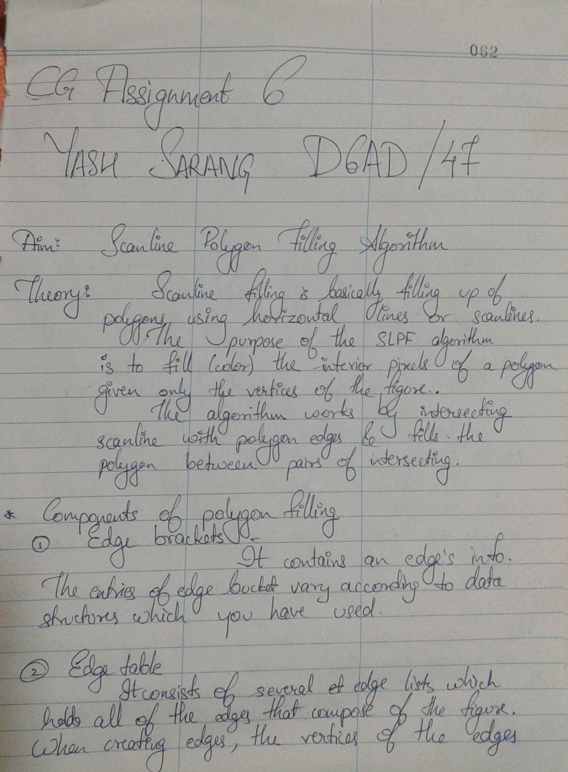

**Code :-**

*#include <stdio.h>*

*#include <conio.h>*

*#include <graphics.h>*

*void main() {*

*int n, i, j, k, gd, gm, dy, dx;*

*int x, y, temp;*

*int a[20][2], xi[20];*

*float slope[20];*

*clrscr();*

*printf("\n\n\tEnter the no. of edges of polygon : ");*

*scanf("%d", & n);*

*printf("\n\n\tEnter the cordinates of polygon :\n\n\n ");*

*for (i = 0; i < n; i++) {*

*printf("\tX%d Y%d : ", i, i);*

*scanf("%d %d", & a[i][0], & a[i][1]);*

*}*

*a[n][0] = a[0][0];*

*a[n][1] = a[0][1];*

*detectgraph( & gd, & gm);*

*initgraph( & gd, & gm, "C:\\TurboC3\\BGI");*

*/*- draw polygon -*/*

*for (i = 0; i < n; i++) {*

*line(a[i][0], a[i][1], a[i + 1][0], a[i + 1][1]);*

*}*

*getch();*

*for (i = 0; i < n; i++) {*

*dy = a[i + 1][1] - a[i][1];*

*dx = a[i + 1][0] - a[i][0];*

*if (dy == 0) slope[i] = 1.0;*

*if (dx == 0) slope[i] = 0.0;*

*if ((dy != 0) && (dx != 0)) /*- calculate inverse slope -*/ {*

*slope[i] = (float) dx / dy;*

*}*

*}*

*for (y = 0; y < 480; y++) {*

*k = 0;*

*for (i = 0; i < n; i++) {*

*if (((a[i][1] <= y) && (a[i + 1][1] > y)) ||*

*((a[i][1] > y) && (a[i + 1][1] <= y))) {*

*xi[k] = (int)(a[i][0] + slope[i] * (y - a[i][1]));*

*k++;*

*}*

*}*

*for (j = 0; j < k - 1; j++) /*- Arrange x-intersections in order -*/*

*for (i = 0; i < k - 1; i++) {*

*if (xi[i] > xi[i + 1]) {*

*temp = xi[i];*

*xi[i] = xi[i + 1];*

*xi[i + 1] = temp;*

*}*

*}*

*setcolor(3);*

*for (i = 0; i < k; i += 2) {*

*line(xi[i], y, xi[i + 1] + 1, y);*

*getch();*

*}*

*}*

*}*

**Output:-**

